Document following:

1. Threshold resolution for responsiveness

Min-width:750px and max-width:999px

Max-width:749px

Mobile: min-width:900px

Min-width:600px and max-width:899px

Max-width:599px

b. Colors for the page. Use color wheel for planning.

#f7ca59 / #ebe460 / #65DBCA / #962EDB

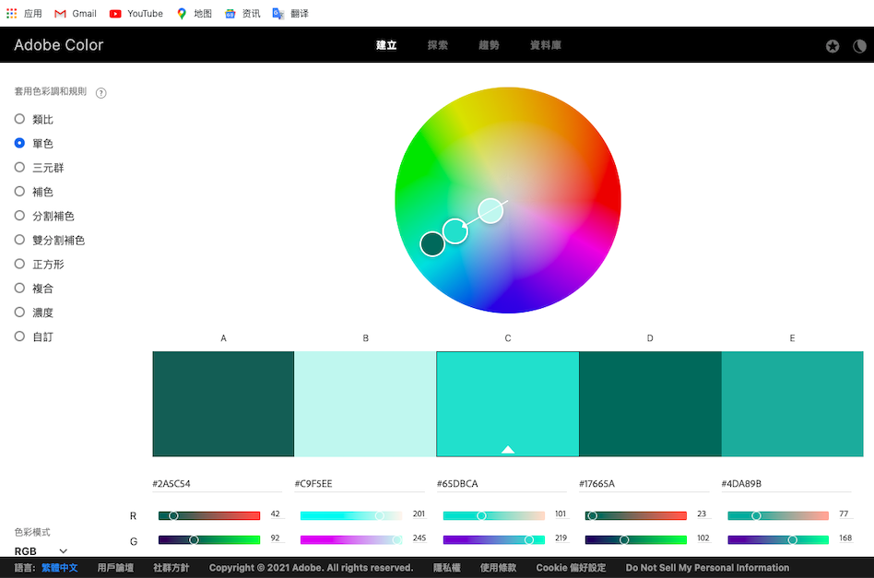

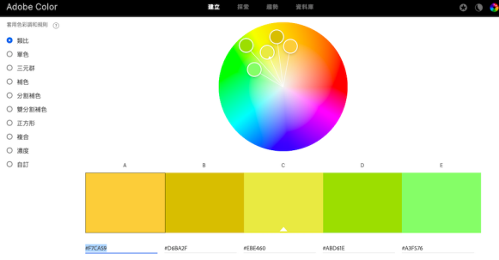

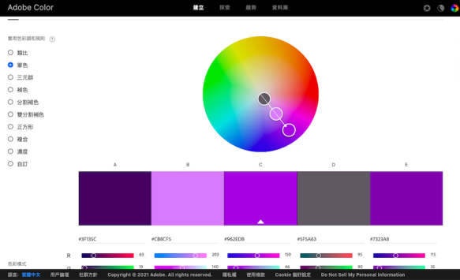

c. Typography: what fonts, font colors and main font sizes you will use.

Header : “Permanent Marker” 60px #f7ca59

Footer : “Inter” 30px #ebe490

Nav : “Inter” 50px

P : “Inter” 18px

Button: “permanent marker” 24px

d. Add images of the UI mockups in the document and link to Figma design.

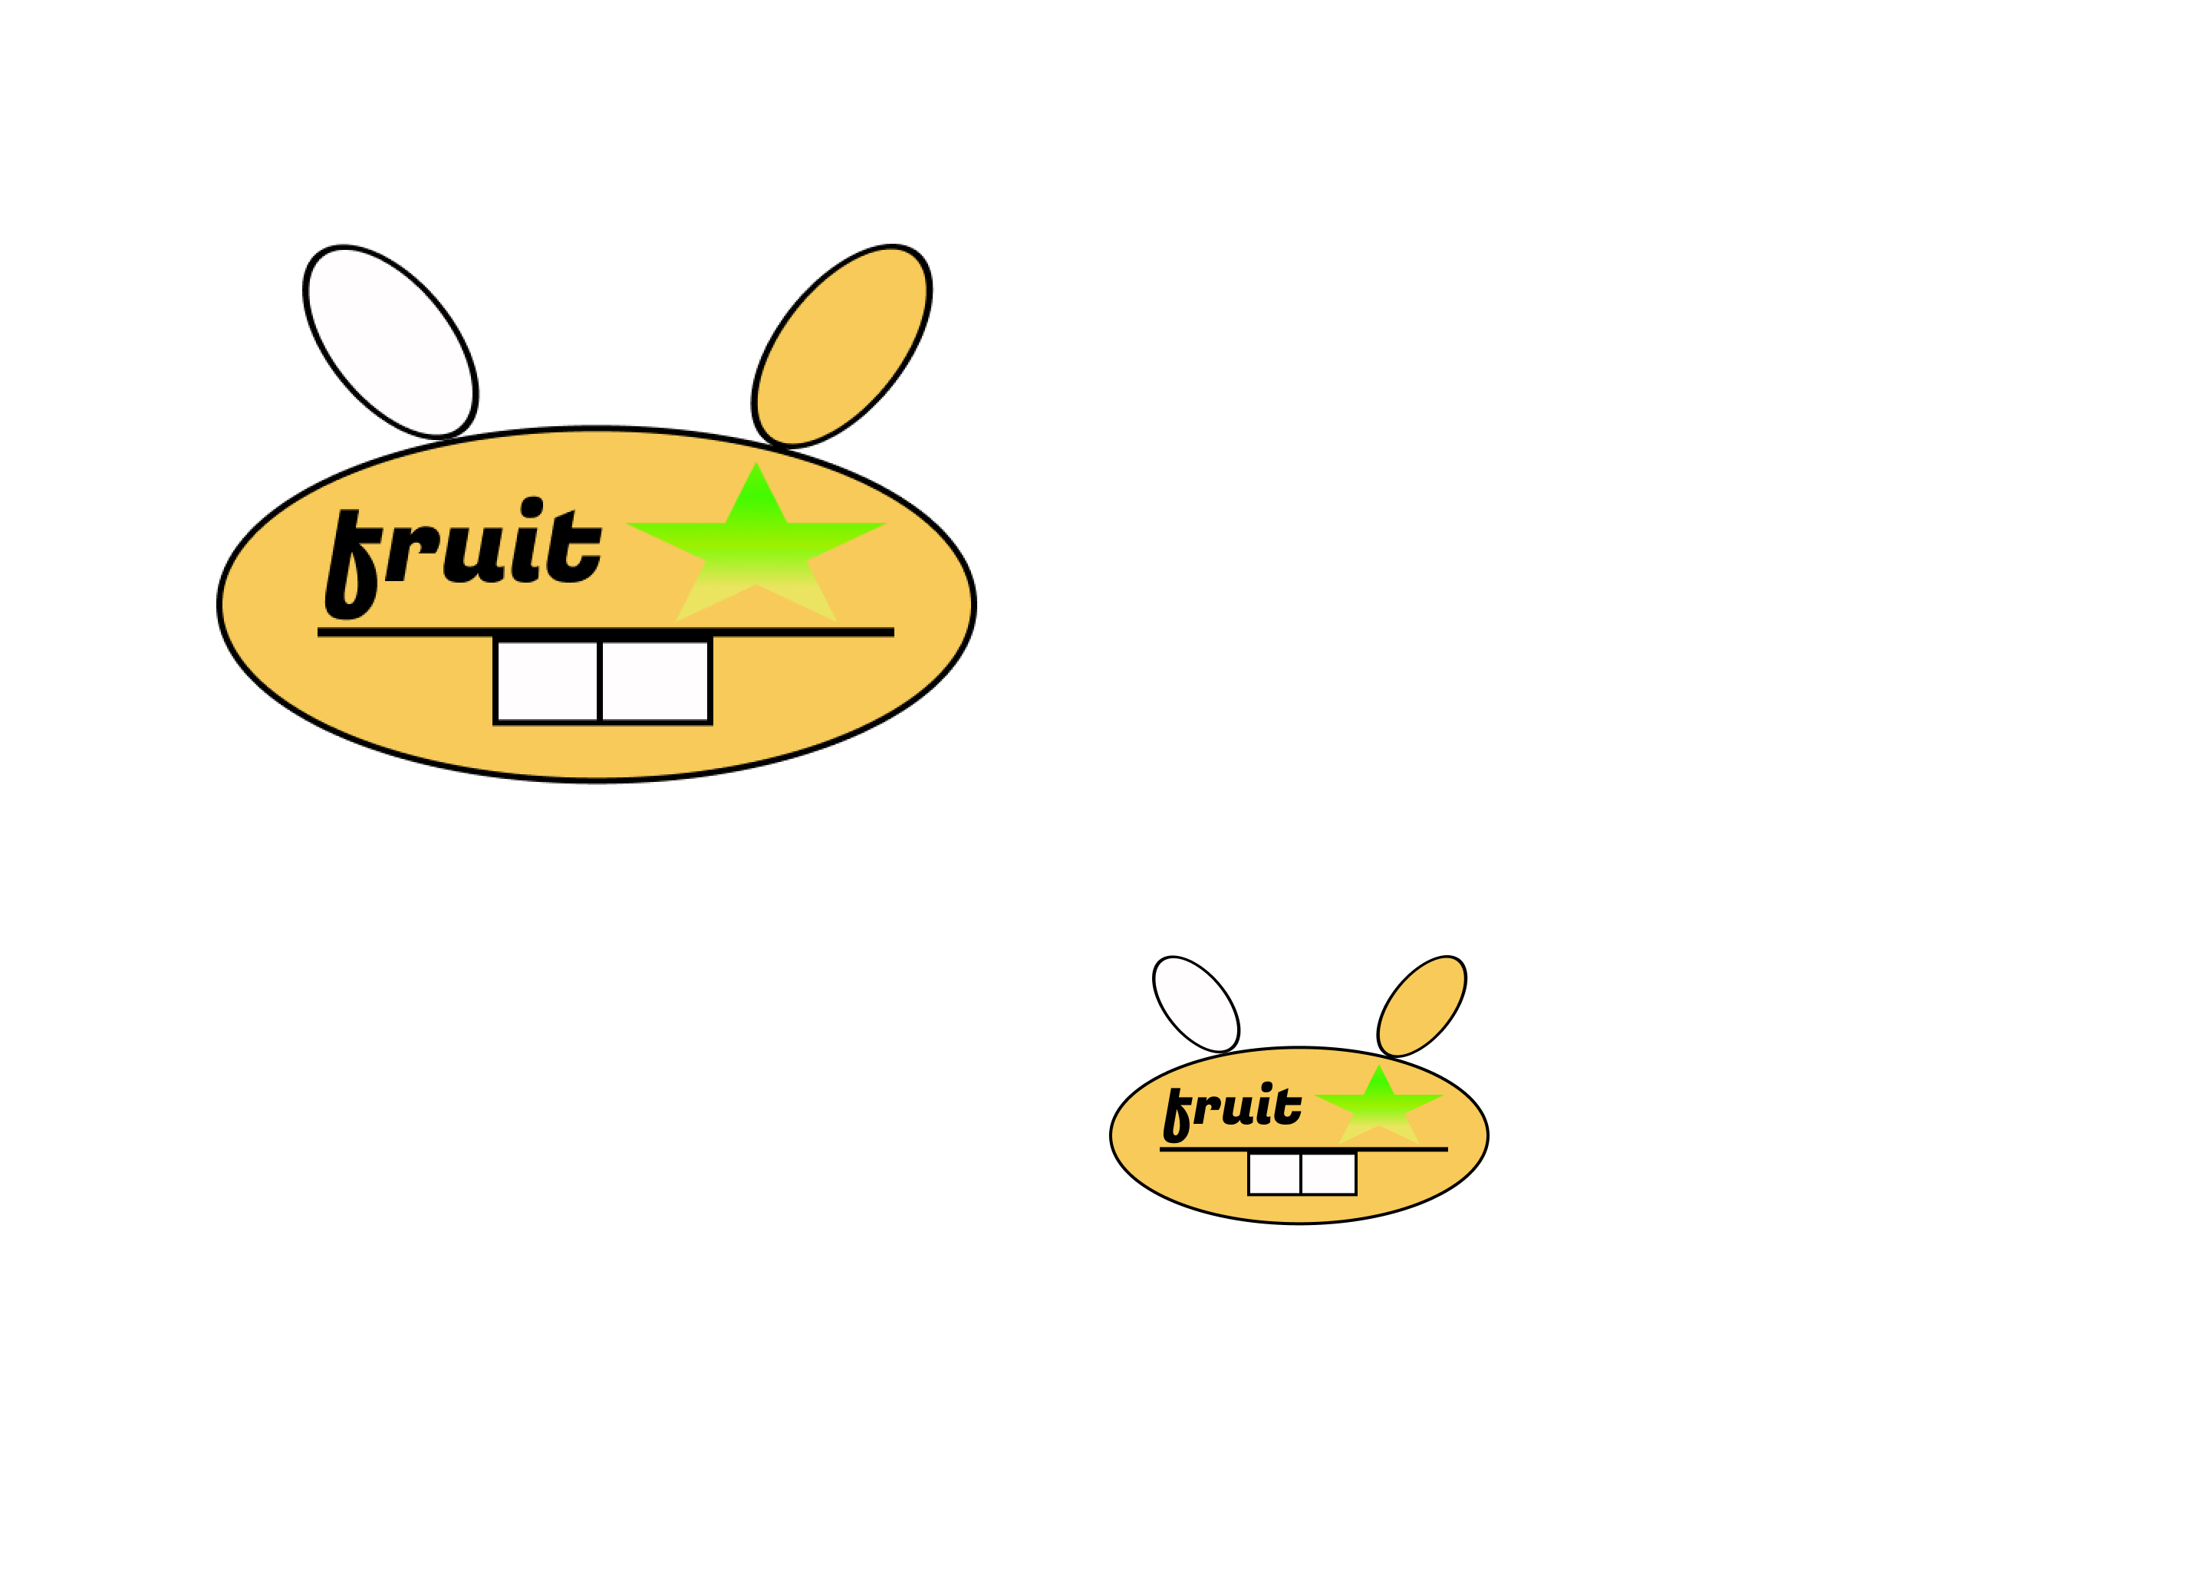

https://www.figma.com/proto/oBabPXNUVQWgTy29mHXqBK/Untitled?page-id=0%3A1&node-id=2%3A2&viewport=241%2C48%2C0.54&scaling=min-zoom

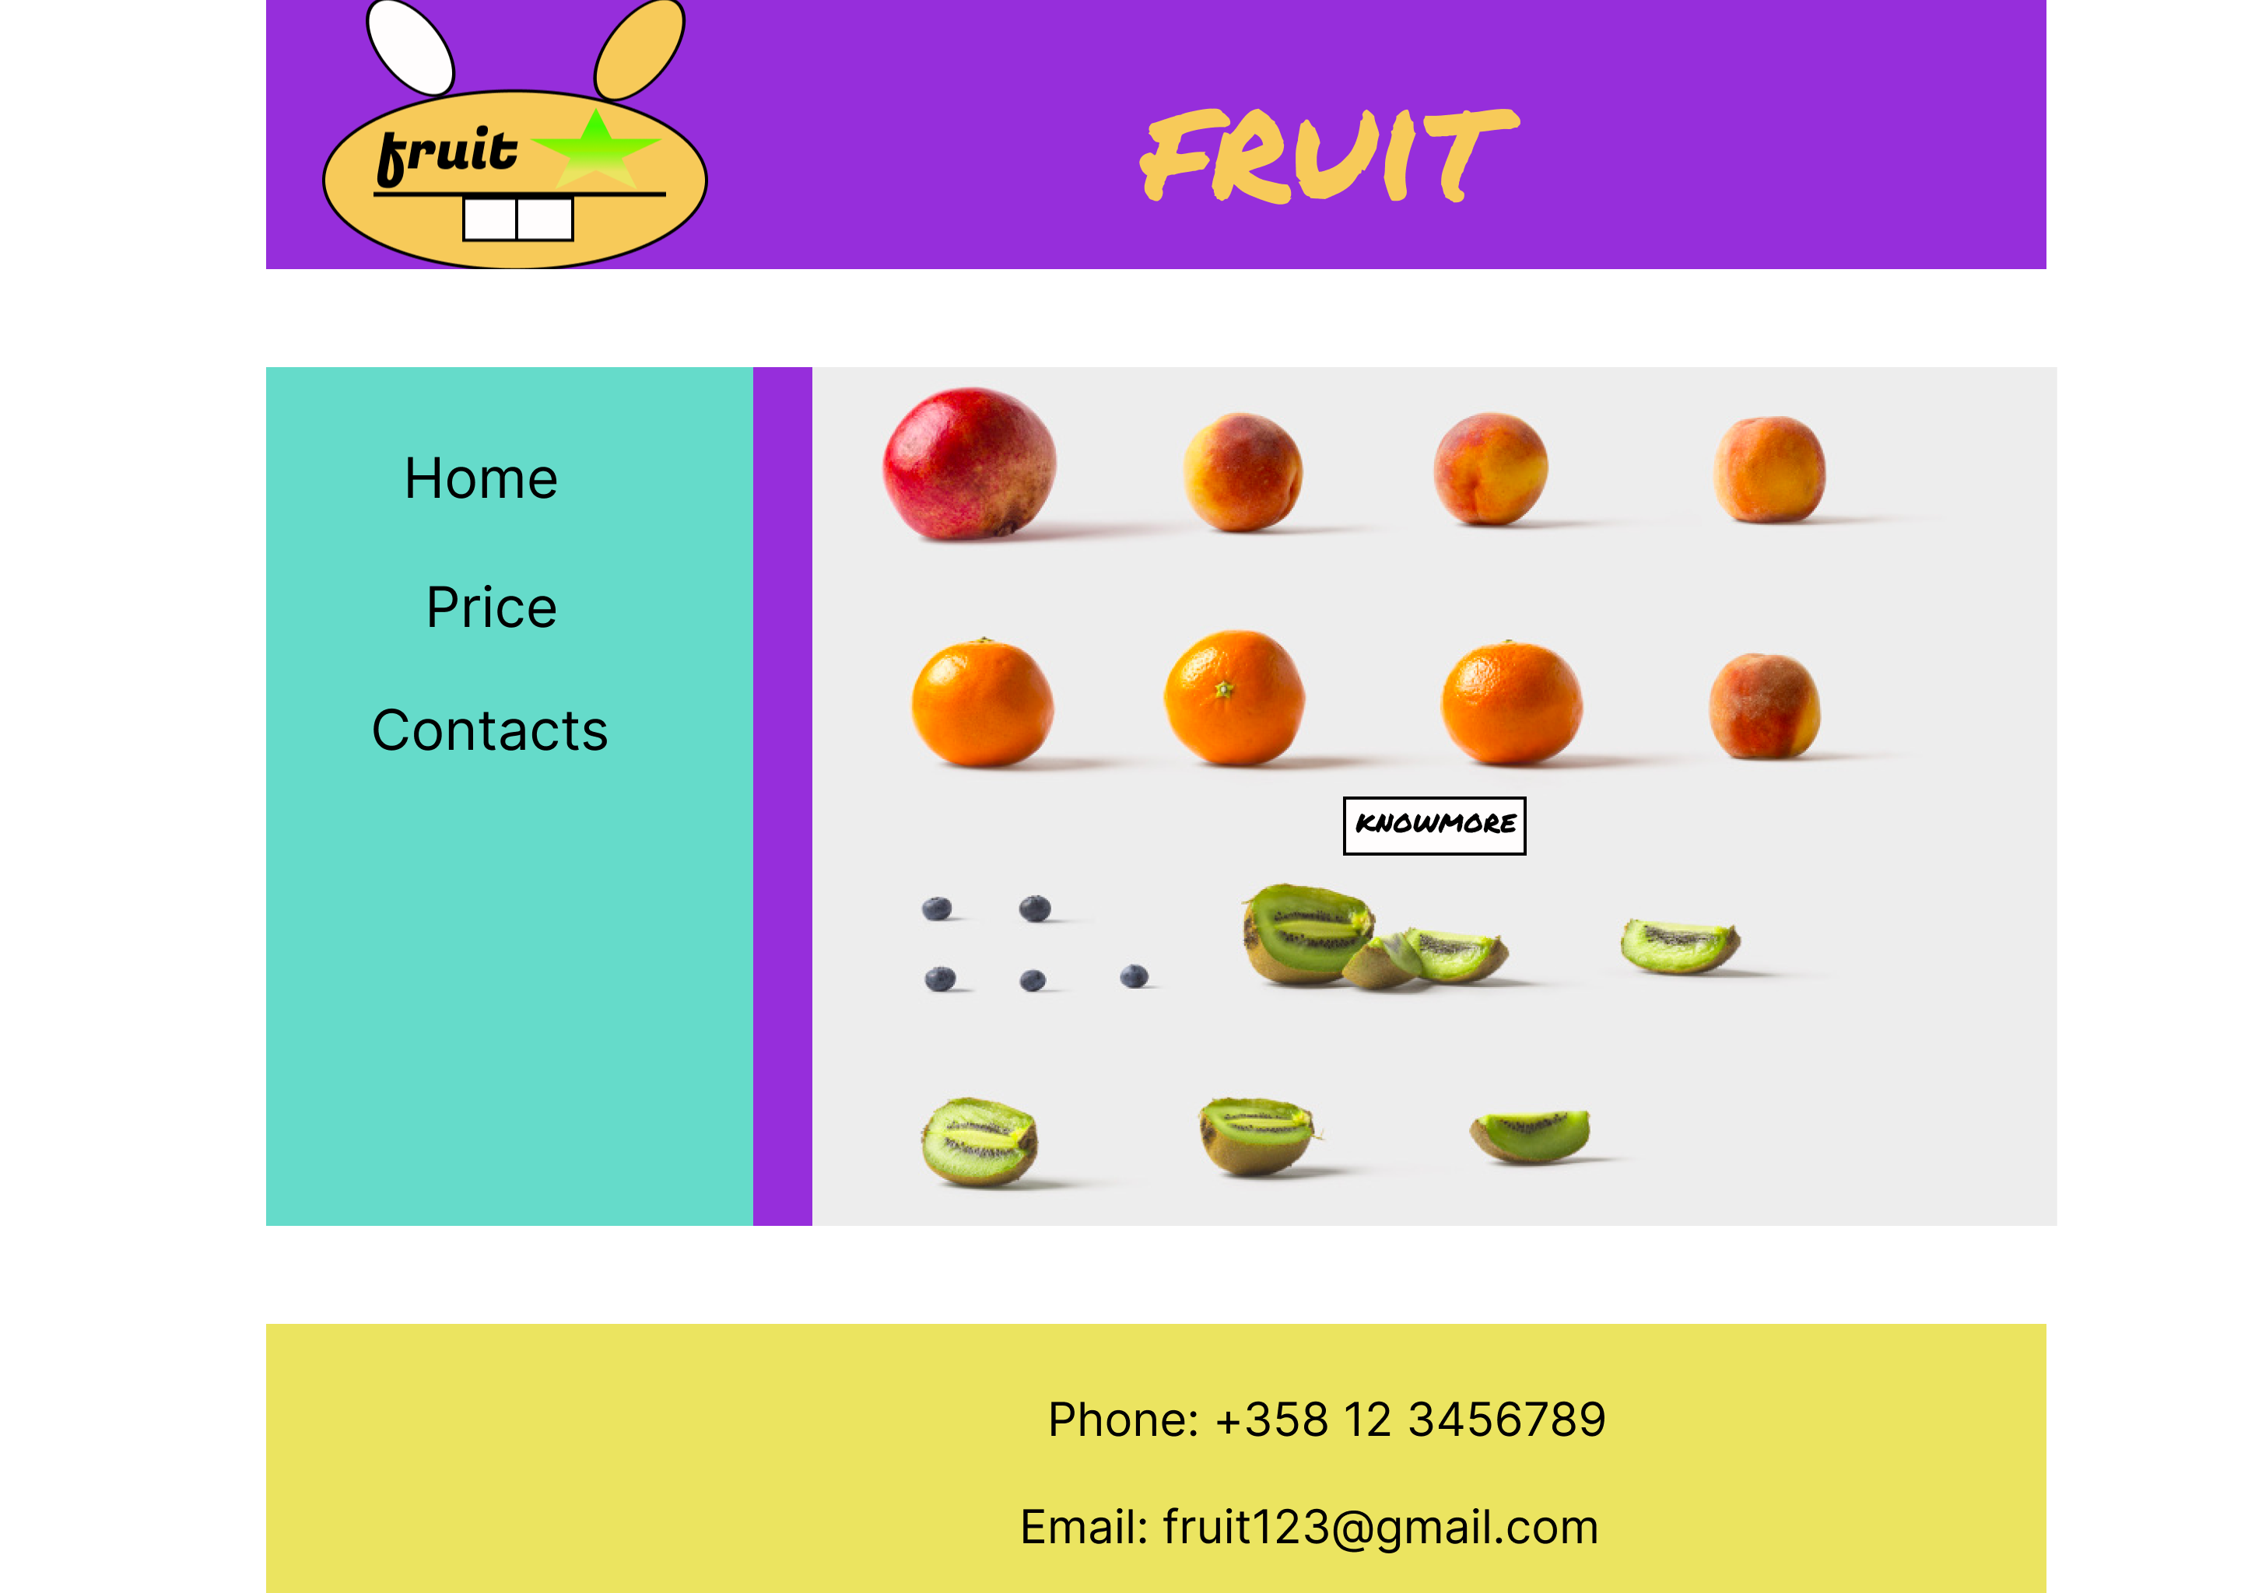

https://www.figma.com/proto/oBabPXNUVQWgTy29mHXqBK/Untitled?page-id=2%3A11&node-id=2%3A12&viewport=241%2C48%2C0.54&scaling=min-zoom

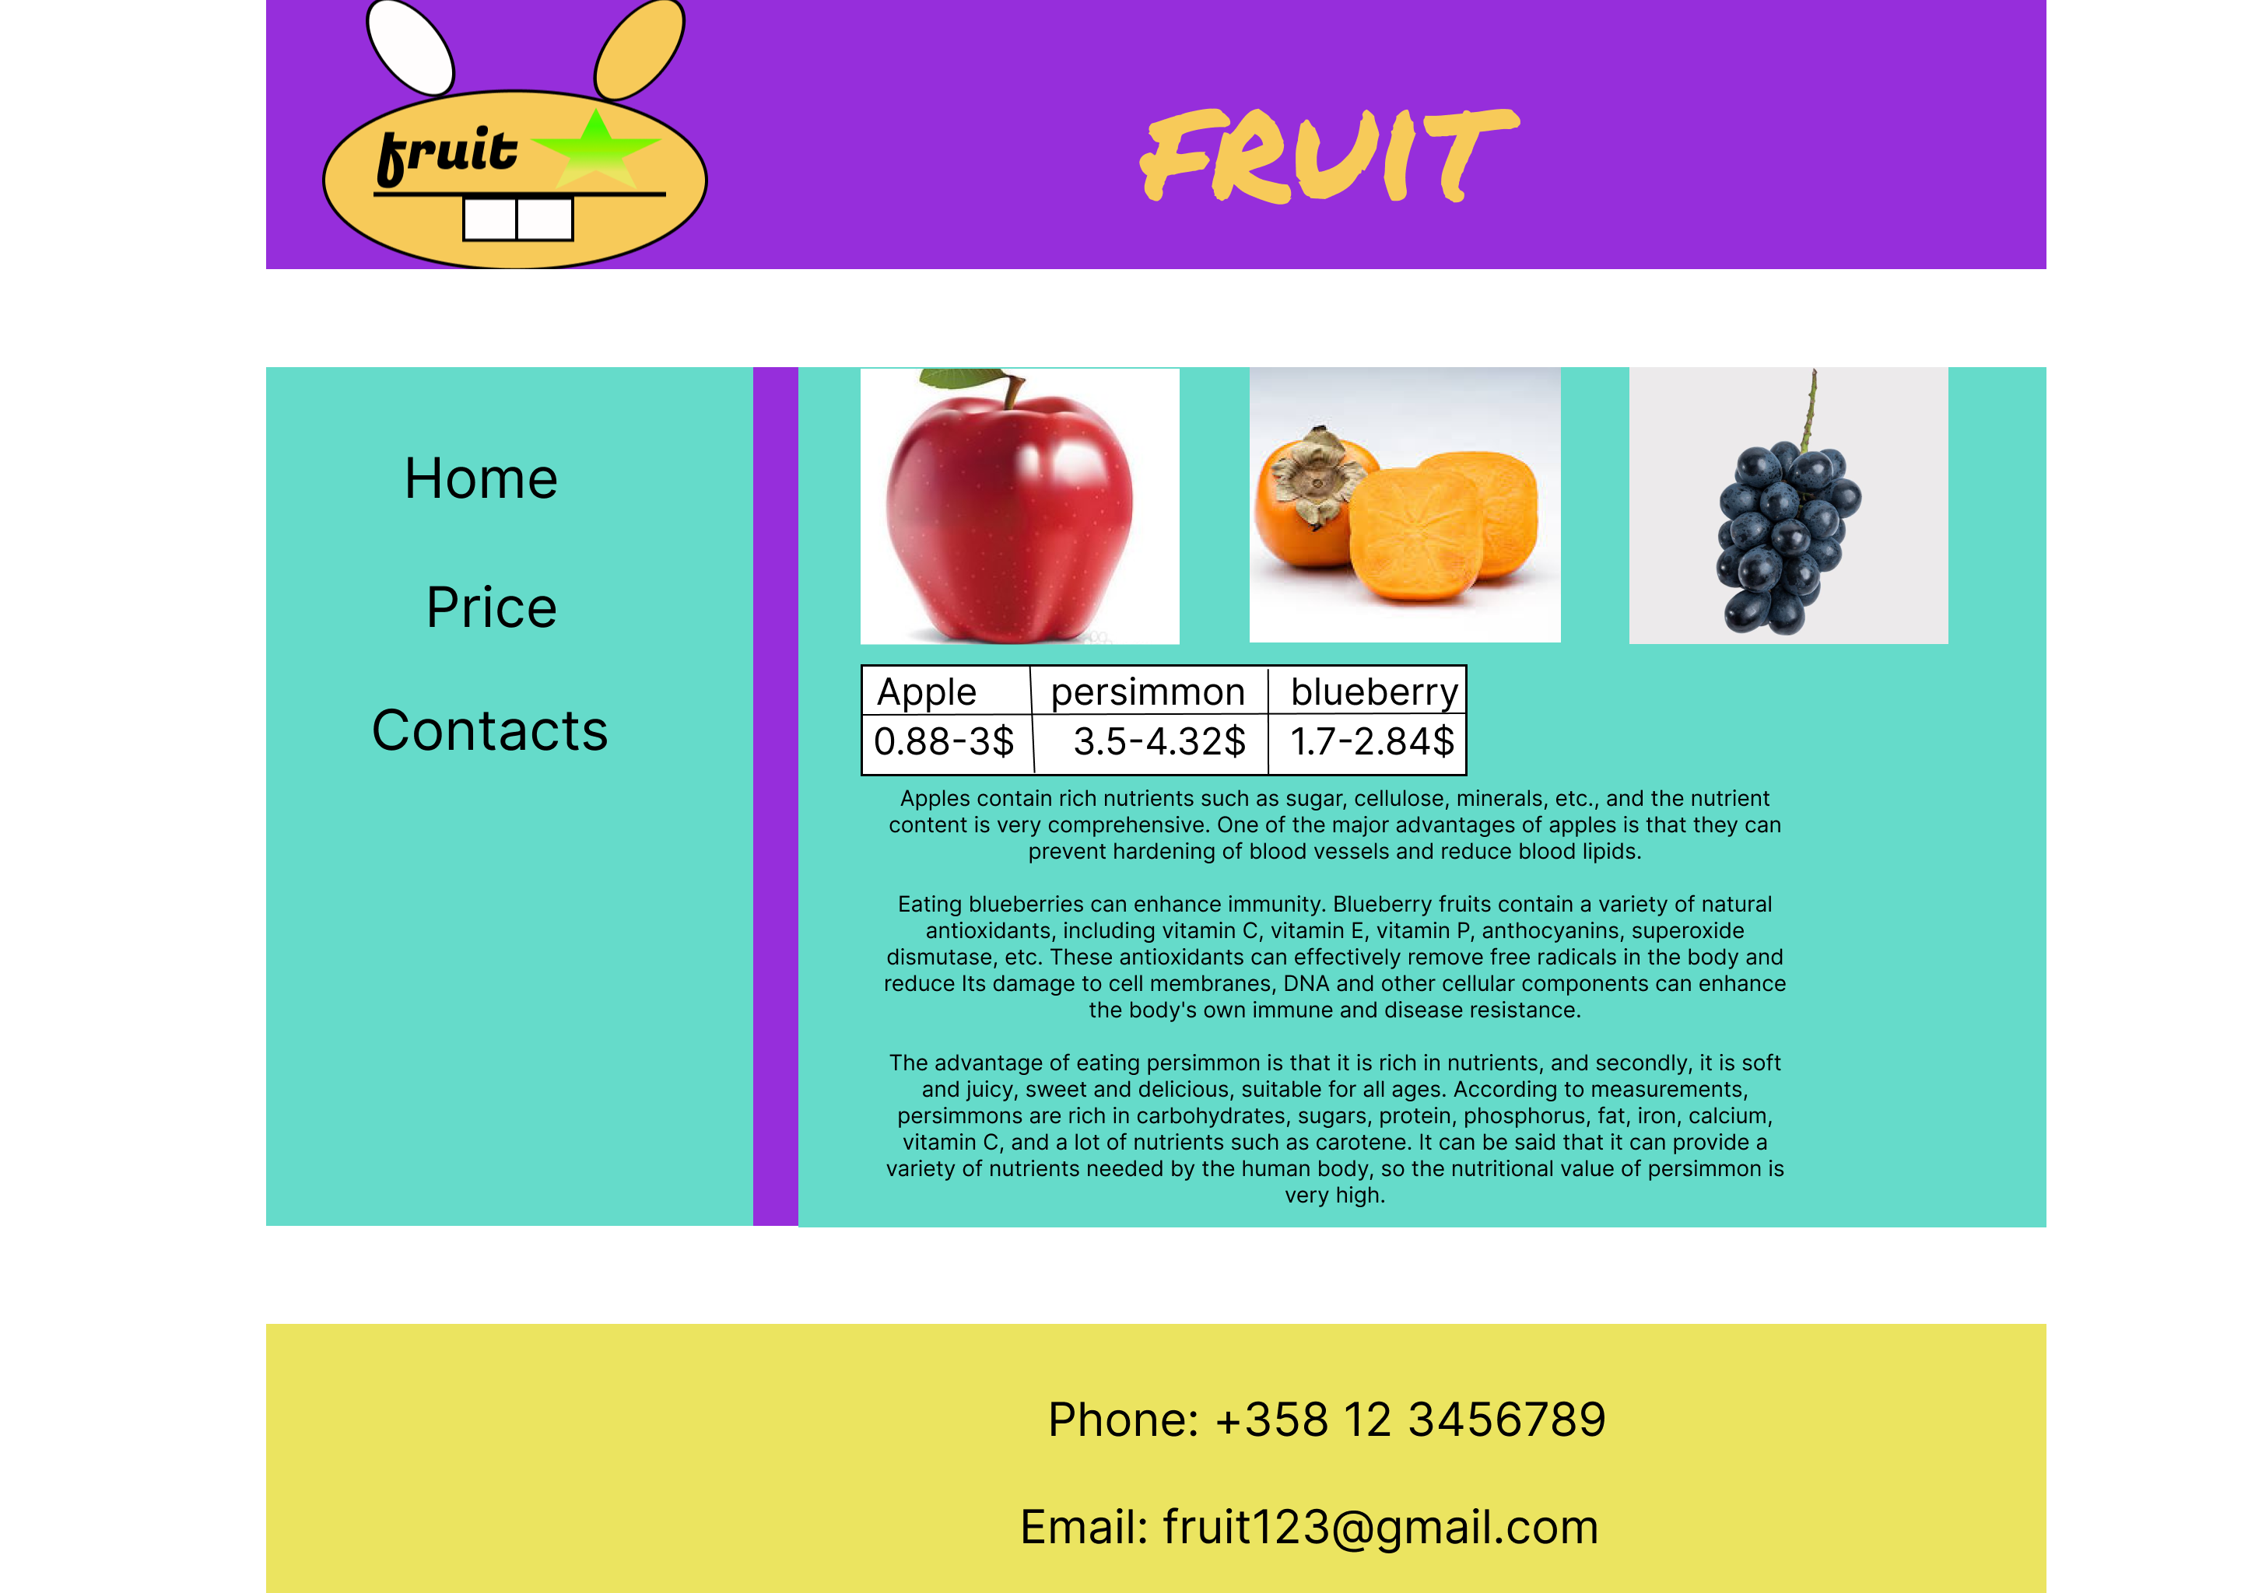

https://www.figma.com/proto/oBabPXNUVQWgTy29mHXqBK/Untitled?page-id=35%3A214&node-id=42%3A244&viewport=241%2C48%2C0.54&scaling=min-zoom

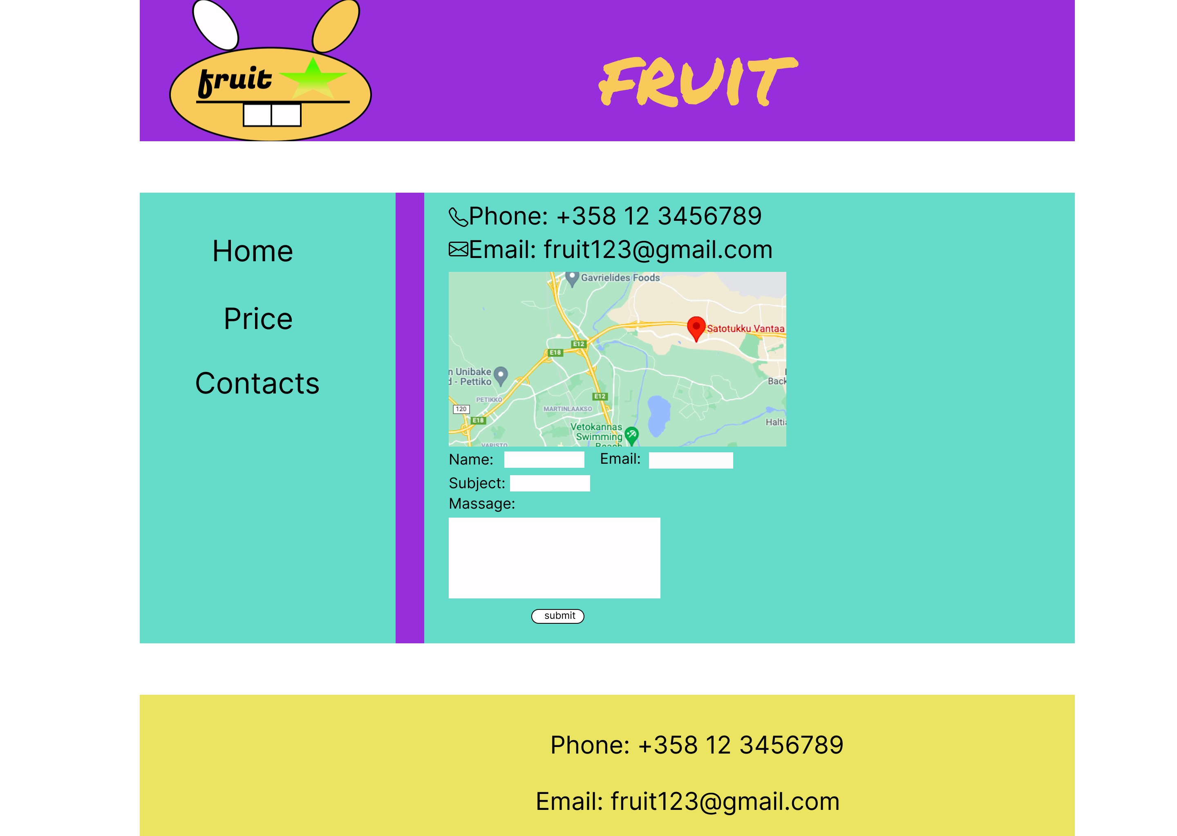

https://www.figma.com/proto/oBabPXNUVQWgTy29mHXqBK/Untitled?page-id=41%3A230&node-id=42%3A275&viewport=241%2C48%2C0.54&scaling=min-zoom

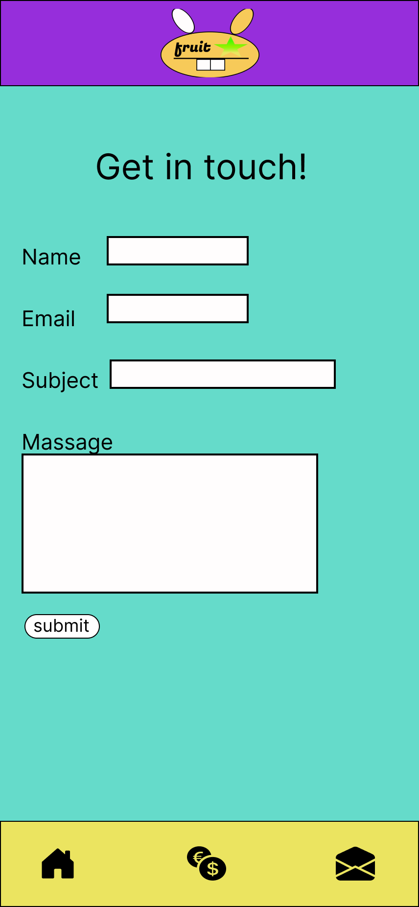

https://www.figma.com/proto/oBabPXNUVQWgTy29mHXqBK/Untitled?page-id=34%3A138&node-id=34%3A139&viewport=241%2C48%2C0.72&scaling=min-zoom

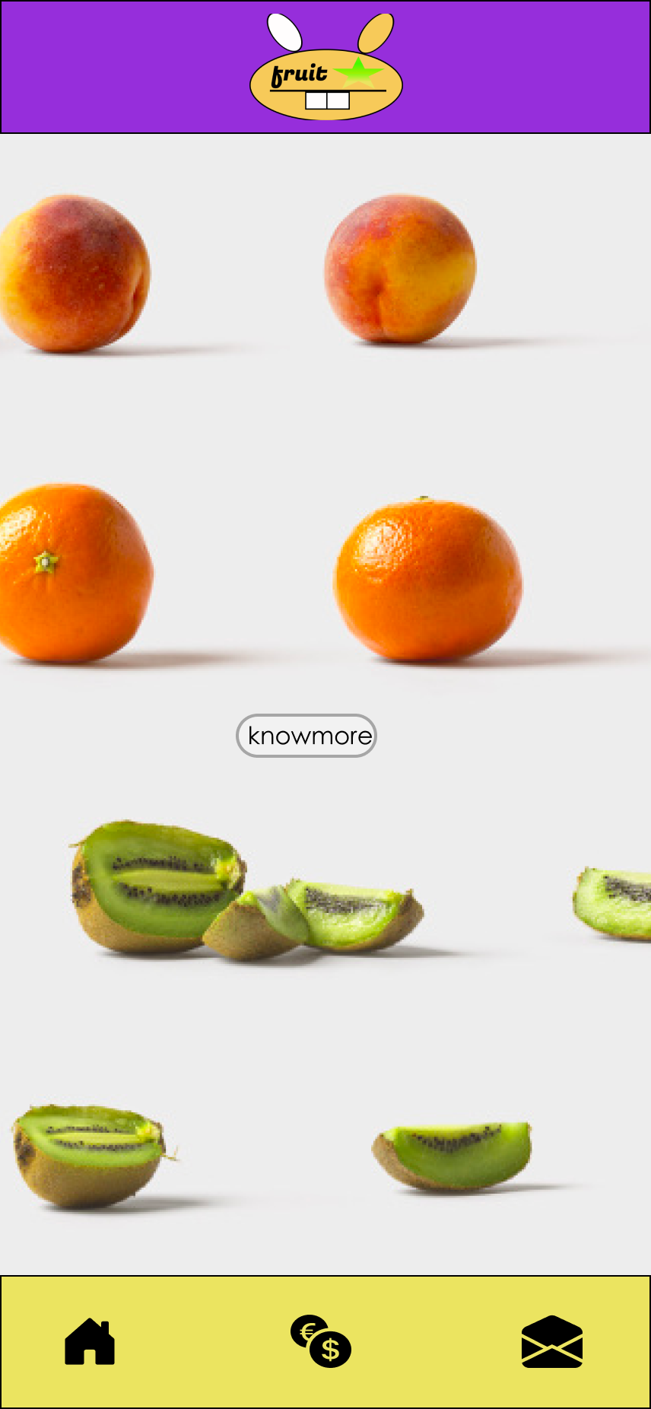

https://www.figma.com/proto/oBabPXNUVQWgTy29mHXqBK/Untitled?page-id=4%3A267&node-id=4%3A268&viewport=241%2C48%2C0.72&scaling=scale-down

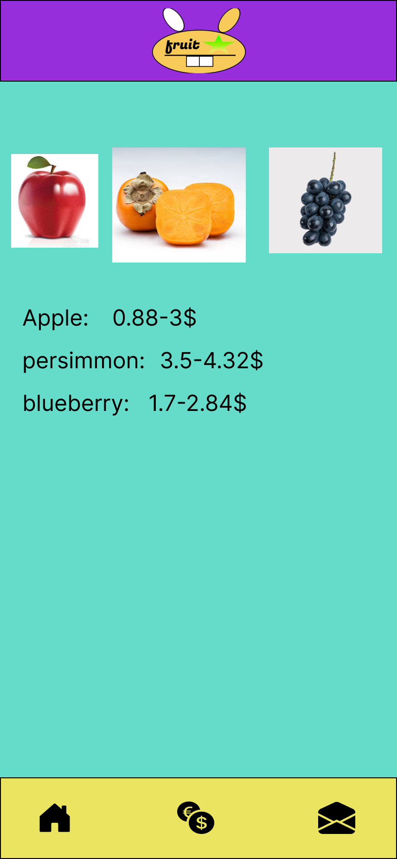

https://www.figma.com/proto/oBabPXNUVQWgTy29mHXqBK/Untitled?page-id=42%3A257&node-id=42%3A258&viewport=241%2C48%2C0.72&scaling=min-zoom

Publish link:<https://yingzhiemily.github.io/html.github.io/>

